# Heavy Weight #1

## **Series #1 w/o strip; Series #2 w/strip**

### Series #1 mean: 82.918 bpm; Series #2 mean: 77.803 bpm

The Series #2 mean has less than a .0001 probability of occurring by chance when compared to the Series #1 mean. This gives strong evidence that the nasal strip decreased the subject’s pulse rate.

### Tidal Volume: Series #1 mean: 675.568 ml; Series #2 mean: 714.1096ml

The Series #2 mean has less than a .0001 probability of occurring by chance when compared to the Series #1 mean. This gives strong evidence that the nasal strip increased the subject’s tidal volume.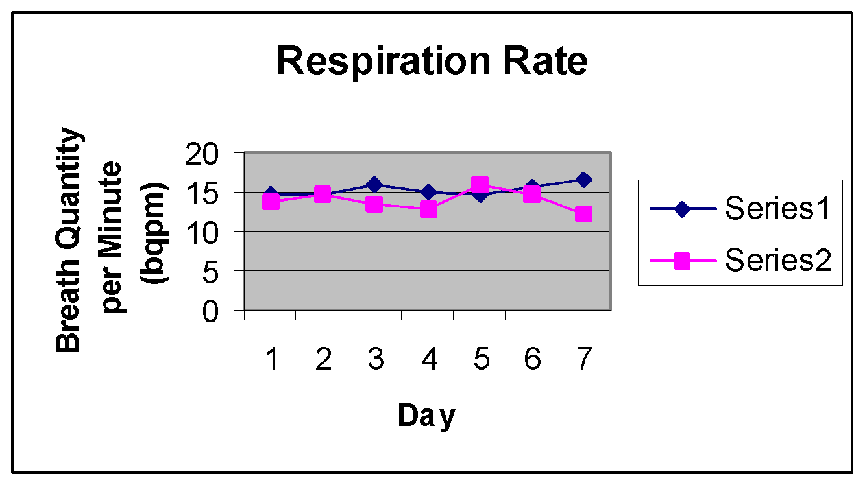

### Series #1 mean: 15.2637 bqpm; Series #2 mean: 13.88214 bqpm

The Series #2 mean has less than a .001 probability of occurring by chance when compared to the Series #1 mean. This gives strong evidence that the nasal strip decreased the subject’s respiratory rate.

### Series #1 mean: 309,275.44 ml; Series #2 mean:297,401.0833ml

The Series #2 mean has a .1435 probability of occurring when compared to the Series #1 mean. This gives weak evidence that the nasal strip either increased or decreased the subject’s 30 minute volume.